CREATING LOAD BALANCER FOR EC2 INSTANCE

1. Create a target group “Host-target-grp” with required configuration with HOST 1 and HOST 2 as “registered target”.

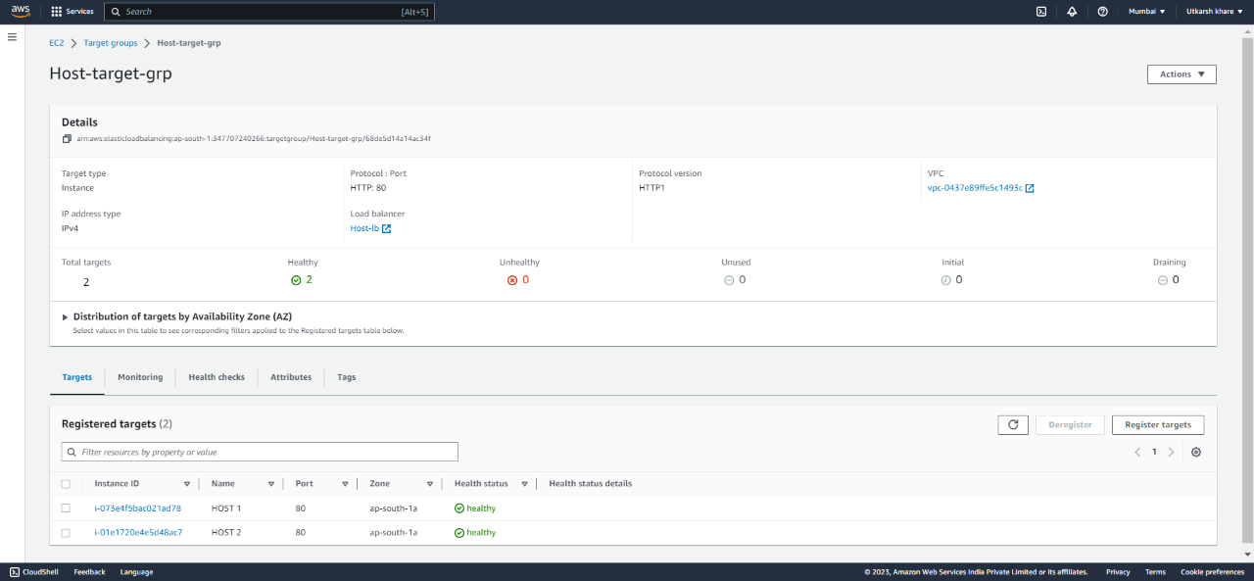

1. Create Application Load balancer named “Host-lb” with required configuration with “Host-target-grp” as target.

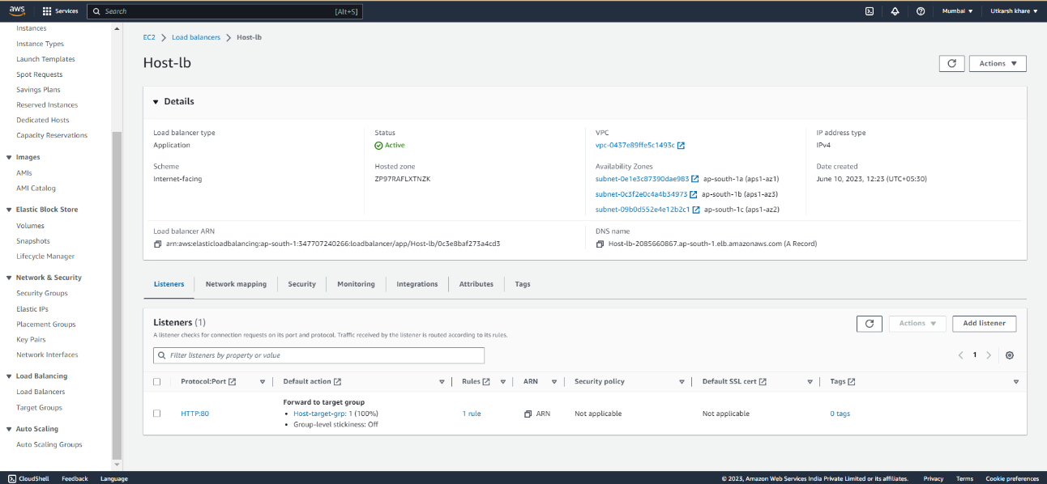

1. Can check if load balancer is working or not by accessing webpage through Load balancer DNS.

If you see website from load balancer DNS it means your load balancer is working properly 😊